POSITION DESCRIPTION
Position: | Director, People and Capability
Department: | People and Capability
Location: | Queenstown
Reports to: | General Manager, Corporate Services
Date: | May 2022

BACKGROUND
Queenstown Lakes District Council (QLDC) is a territorial authority in Te Waipounamu South Island of Aotearoa New Zealand, with a current resident population of approximately 40,750 which is projected to increase to 53,510 by 2031. The Queenstown Lakes District is also a premier tourist destination making a significant contribution to the national economy. In recent years, the district has undergone significant and sustained growth in both resident population and in international and domestic visitor numbers. On a peak day in 2018, visitor numbers totalled 79,300 which is projected to reach 91,270 on a peak day in 2031. The overall growth pressures the district is experiencing has led to the draft 2021 -2031 Ten Year Plan setting out an ambitious programme of work, with over $1.6 billion of capital investment to be made over the decade.
QLDC has a central role to play in maintaining and enhancing the quality and liveability of the outstanding environment of the district. It also has a central role in development and regulation and provides high quality services and infrastructure to residents and visitors; managing the district’s parks, trails, libraries and recreational facilities; enabling sustainable development through consenting services; and regulating local activities. QLDC’s role in leading the recovery effort for the district in response to COVID-19, also means that the diversification of the district’s economy is an increasingly important priority for our Council.
The community outcomes set out in the 2021 – 2031 Ten Year Plan are directly extracted from Vision Beyond 2050, which is our community vision statement:
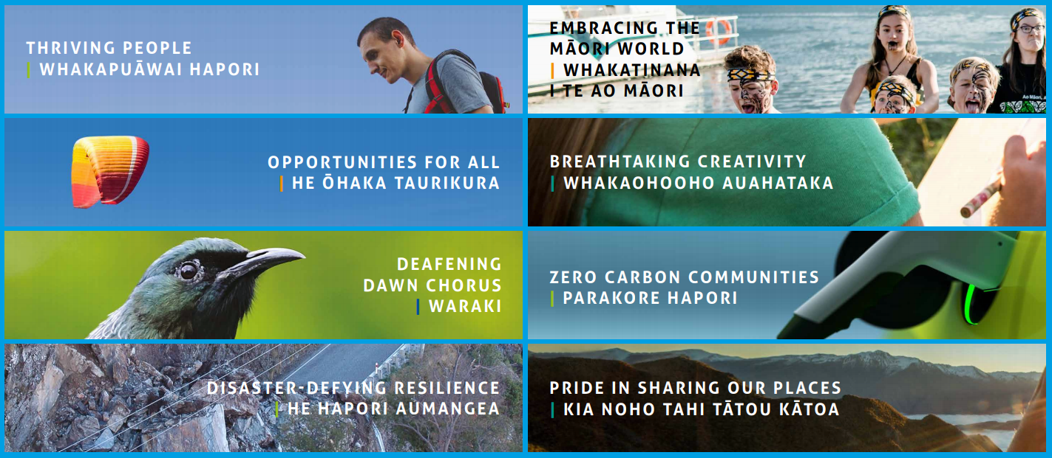

VISION, MISSION AND VALUES
We’re proud to be QLDC, and in response to the growth the district has experienced over recent years the QLDC organisation has itself experienced substantial growth. With an employed workforce of approximately 400 FTE in January 2021, and a range of partner organisations delivering services on behalf of Council, QLDC is also a significant employer in the district. The range and types of work carried out at QLDC are extensive, and complex; becoming increasingly so as the district continues to grow.
Our culture is an important part of who we are. The vision, mission and values set out below are the foundation for our organisational culture; how and why we go about things:
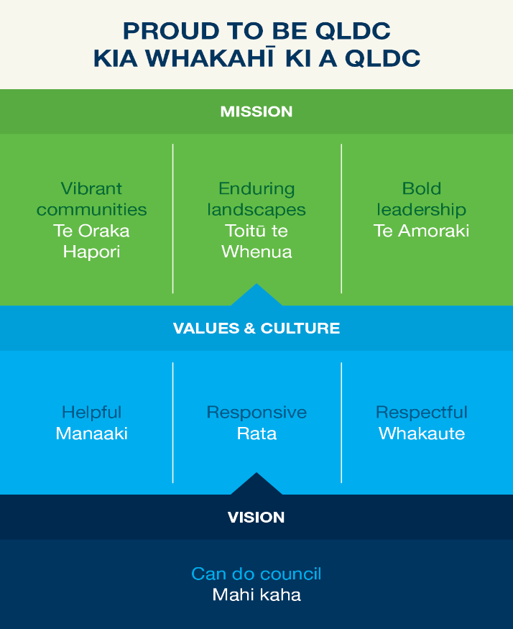
PURPOSE
The Director, People and Capability role will lead the delivery of strategies and programmes that will support and develop the staff of QLDC in a manner that helps them to excel in the achievement of the organisation’s business strategies. The key areas of intervention that the Director, People and Capability is accountable for are:
- Organisational development strategy, including organisational and job design
- Workforce planning
- Workplace strategy
- Sourcing and selection strategy
- Capability development including the induction framework, competency model, capability programmes, leadership development framework and talent identification and management framework
- Health and Safety organisational compliance enablement and engagement
- Wellbeing framework
- Human resource advisory and compliance
The role will ensure that appropriate people management policies, practices, systems and procedures are in place; and will also lead strategic thinking around HR policy, practices and ensuring alignment with organisational strategic direction. All processes will be exemplary and delivery exacting. The role directly influences and impacts on the reputation of the organisation through interaction with Elected Members, the staff and community stakeholders.
The Director, People and Capability has a strong change and people leadership focus and will directly influence the Executive Leadership Team in the key areas as outlined. The role also holds reporting line responsibility for the Executive Assistant to the Mayor, Executive Assistant to the Chief Executive and Executive Assistant/Corporate Administration support to the General Manager Corporate Services.
KEY TASKS
Strategic Leadership
- Lead the development of strategic organisational development/human resource planning for QLDC and ensure input into the overall organisational strategy, identifying the required resourcing, skills, knowledge and aptitude required to deliver on immediate and future objectives.
- Support the Chief Executive, Executive Leadership Team and Managers through effective organisational development strategies to deliver on QLDC’s vision and objectives.
- Work with Chief Executive and ELT to enhance leadership and talent bench strength through talent and succession planning and leadership/learning development initiatives.
- Lead and develop a culture and values for the organisation, including the People and Capability department that enhances collaboration and best practice organisational development and human resource services delivery. Provide leadership and decision-making which reflects and delivers the objectives and values of QLDC.
- Has collective responsibility with QLDC’s Executive leadership team, for the consideration of key issues facing the organisation, to ensure that immediate and longer term implications, opportunities and risks are fully considered and consistent with the organisational development / human resource strategy.
- Delivery of workforce strategy, with a particular focus on:
  - Monitoring and evaluation of performance against strategy
  - Ongoing review of strategy
  - Remuneration
  - Performance management
  - Talent attraction and retention
  - Succession planning
  - Contractor engagement as part of QLDC workforce
- Lead QLDC’s remuneration strategy including ownership of organisation-wide staff resourcing and salaries and wages budget planning as part of the ten year and annual plan processes.
- Oversee delivery of the workforce review, including the change and implementation programme.
- Oversee QLDC’s organisation development programme, including key organisation development initiatives identified in workforce strategy.
- Health & Safety strategy, and oversight of operational delivery in this space.
- Wellbeing strategy, and oversight of programme delivery.
- Leadership of the Executive Assistant team.
- Governance and Executive reporting on People and Capability activities.
- Lead/oversee service delivery in all areas of People and Capability.
- Lead technology systems improvements across People and Capability functions –in particular HR and H&S.
- Lead workforce preparation for 3W and other reform programmes.
- Provide technical HR support to Chief Executive in matters relating to Executive Leadership Team; and to Mayor in respect of Chief Executive.
- Lead the collective bargaining and union relationship.
- Has role-share responsibility with CIO as Business Continuity Response Manager.
- Develop and manage the People and Capability budget.
- Lead the development of workforce requirements against the work programme for the Ten Year Plan and the Annual Plan. Lead development of resourcing requirements and remuneration inputs to the salaries and wages budget.
Operational Excellence
- Ensure the efficient and effective development and delivery of organisational development and human resource activities to QLDC managers and staff.
- Ensure efficient and effective service delivery in the administration & support services provided to the Mayor and Chief Executive through their respective Executive Assistants.
- Provide an effective operational HR business partnering offering, including delivery of all HR operational support and business as usual advice to the business throughout the employee life cycle, including recruitment, employee relations, health and safety, performance management, learning and development, remuneration and succession planning.
- Oversee the implementation of organisational development/human resource initiatives and programme that support QLDC’s organisational strategies and performance.
- Ensure an effective health and safety framework is in operation throughout the organisation, enabling QLDC to meet its obligations with respect to staff and contractors.
- Ensure delivery of annual performance management, remuneration reviews and professional development programmes at QLDC.
- Ensure payroll processing is conducted in a timely and accurate manner, in accordance with QLDC policies.
- Champion QLDC commitment to excellence, innovation and quality. Is a change catalyst inspiring improvement and new directions.
- Implement and continually improve service delivery policies, processes and systems in order to provide effective, efficient and seamless organisational development and human resource services.
- By overseeing exemplary HR Team performance and influencing exemplary organisational employment processes, mitigate the risk of challenge and litigation.

Relationship Management
- Build and maintain a strong and productive working relationship with the QLDC leadership team and staff.
- Strategically manage relationships through on-going dialogue. Take a long term perspective in ensuring delivery, satisfaction and value for money.
- Maintain key networks with other organisational development and human resource providers, in order to identify opportunities for collaboration and service improvement.
- Cultivate a professional and positive image for QLDC with the media and the community.
Business Unit Management
- Continually monitors the allocation and performance of resources (both people and facilities) and the achievement of agreed targets and quality standards. Provide appropriate reporting to the Chief Executive on the performance of the business area.
- Capability building – Ensures the People and Capability department is structured appropriately, has in place the appropriate operating model and management structures and the necessary financial, human, technical and service delivery capabilities to deliver its outcomes.
- Financial management – Accountable for the HR and HSW department budgets, managing within defined parameters and ensuring efficient and effective use of financial resources.
- Risk management – Ensure appropriate frameworks and processes are in place to effectively identify and manage risks to the department and QLDC’s reputation and achievement of its programme of work.
- Human resource and Corporate EA management – Accountable for the successful management of employees within the department; establishing and leading a high performing team through coaching, mentoring and motivating; and implementing QLDC’s performance management system effectively.
- Ensure procurement processes deliver best value for money. Has oversight of the arrangements with contractors and ensures that these contracts are being appropriately implemented, managed and reviewed.
- Encourage and foster a climate of high performance, high personal satisfaction and open communication amongst all staff.
Corporate Responsibilities
- Build commitment to QLDC’s vision, values and services.
- Willingly undertake any duty required within the context of the position.
- Ensure compliance with all legal/statutory and QLDC requirements for health and safety of all staff, visitors and users of QLDC recreation and leisure facilities.
- Manage own personal health and safety and takes appropriate action to deal with workplace hazards, accidents and incidents.
- Comply with all legislative requirements.
- Adhere to QLDC’s Code of Conduct.

Health, Safety and Wellbeing
- Lead and foster a health, safety and wellbeing culture at QLDC that is practical and safe at all times.
- Lead the People and Capability team in fostering good safety management practices and enable a focus on wellbeing across the organisation.
- Lead the Health and Safety Officer in delivery of a safety and wellbeing framework that supports achievement of agreed organisational health and safety objectives.
- Provide coaching, advice and support to the health and safety officer, ELT, managers, and the health and safety committee in the delivery of effective health, safety and wellbeing practices.
- Ensure ongoing compliance with the Health and Safety at Work Act, and all associated legislation and regulations. Responsible for ensuring knowledge is up to date and relevant.
KEY RELATIONSHIPS
Internal:
- Chief Executive
- General Manager, Corporate Services
- Mayor and Councillors
- QLDC’s Executive Leadership Team
- People & capability team
- Payroll team
- Managers and Staff across the organisation
External:
- Recruitment service providers
- Technology One
- Learning and development providers
- HR and OD professionals in both the public and private sector
- Employment stakeholders (including Chambers of Commerce RTO’s)
- Relevant Government Departments including but not restricted to Internal Affairs and MBIE
- Government reform organisations, including Three Waters National Transition Unit (NTU)
ACCOUNTABILITIES AND DELEGATIONS
Financial and statutory delegations assigned by the Chief Executive will be exercised appropriately and within defined parameters.
Financial Authority
- CEO Sub-Delegations Category B
In conjunction with the General Manager, Corporate Services, agree and manage annual budget for the Human Resources department of approximately $1,450,000. Delegated authority to authorise and sign employment documentation, including employment offers.
Staff management:
Number of direct reports: 7 direct reports
Total number of staff reporting: 13 staff
PERSON SPECIFICATION
- Tertiary qualification in human resource / organisational development or related discipline.
- Extensive experience (10 + years) in leading and managing strategic human resource functions.
- Demonstrated strategic thinking skills and experience in leading significant organisational change initiatives.
- Proven experience in HR and organisational strategy development.
- Demonstrated experience in handling complex HR matters independently and with limited guidance.
- Proven track record of leading through change and driving service improvements.
- Proven track record of developing and maintaining relationships across a broad range of stakeholders across the organisation.
- Extensive networks in, and credibility with the stakeholder community.
- Demonstrated strong political awareness, business acumen and strategic agility.
- Excellent communications skills – both written and oral.
- Proven track record of driving and managing business process and cultural change within an organisation.
- Experience leading and managing a team including all aspects of staff and resource management.
- Broad general management skills including budget management and people leadership.
- Highly motivated, achievement-oriented and innovative professional.
COMPETENCIES
QLDC’s competency framework is built around 15 core behavioural competencies, identified below. Seven of these competencies, highlighted in green below, are core requirements for all staff and roles at QLDC. The role of General Manager, as a member of the Executive Leadership Team also calls on all remaining eight behavioural competencies in order to successfully lead and contribute to the organisation in a senior leadership role.
QLDC Competency Framework:
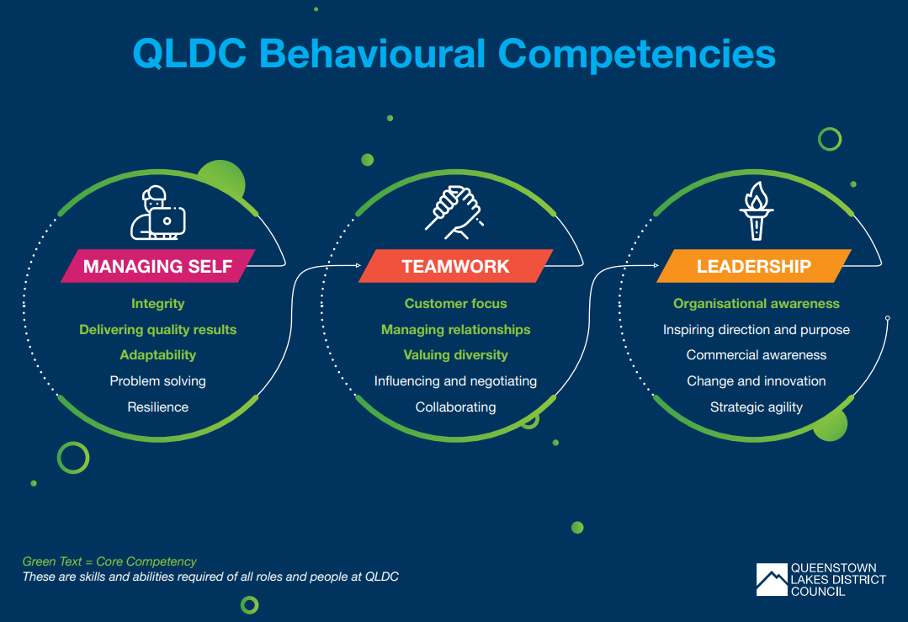

The competency framework is based on a ‘building block’ approach. There are degrees, or levels, to which our people need to demonstrate maturity in each competency based on the requirements of their role. The role of General Manager requires the highest level of maturity set out for all competencies. Examples and explanations for each competency follow:
Managing Self
Competency | Behaviours and expectations in this role
Integrity  Maintaining professional behaviour and ethical standards in everything we do. Acting honesty, fairly and consistently | - Champions and acts as an advocate for the highest standards of ethical and professional behaviour and reinforces them in others  - Challenges and steers influential partners to act on values and recognise QLDC’s wider community accountabilities  - Demonstrates belief in, and commitment to QLDC’s vision, mission and values, and always behaves accordingly
Delivering quality results  A demonstrated desire to set and meet goals, to improve performance and achieve a standard of excellence. | - Creates an environment that stimulates and encourages continuous improvement  - Raises the standards of excellence within QLDC by working hard to collectively achieve objectives  - Identifies and removes potential barriers or hurdles to on-going and long-term achievement of objectives
Adaptability  The ability to adapt to and work with a variety of individuals, groups and situations. Being able to think on your feet and not being disconcerted or stopped by the unexpected. | - Adapts organisational strategies/plans in a way that appropriately addresses changing organisational priorities  - Creates and environment in with others can be comfortable with and open to change  - Creates a clear vision of change – aligning others and defining a clear path for implementation
Problem Solving  The ability look beyond the obvious and to establish what is at the core of an issue. Driven by the desire to know more about the circumstances that impact QLDC, our customers and community. | - Engages on critical analysis of complex issues, weighs up alternatives and identifies the most effective solutions  - Absorptive Capacity – Recognises the value of new information, assimilates it and applies it to obtain a benefit and / or achieve an outcome for the wider community.  - Works with others to solve problems across department boundaries
Resilience  The ability to strike a balance between knowing when it is appropriate to ‘call a halt’ on something and persisting in the face of difficulty to ensure the achievement of desired results. | - Acts as a stabilising influence even in the most challenging situations  - Responds to significant, complex and / or new challenges with high levels of resilience and perseverance  - Tries different approaches to overcome current obstacles and persists with efforts until an effective solution is found

Teamwork
Competency | Behaviours and expectations in this role
Customer Focus  Putting the customer at the heart of everything we do. Ensuring the needs of internal and external customers are prioritised | - Ensures actions, processes and decisions deliver sustainable customer satisfaction and support QLDC’s interests  - Actively supports cross boundary collaboration at all levels of QLDC to provide solutions to customers  - Creates a culture which embodies the delivery of a high quality customer experience across QLDC
Managing relationships  Establishes and maintains effective working relationships to deliver results | - Ensures actions, processes and decisions deliver sustainable relationships and support QLDC’s interests  - Develops reciprocal, long-term relationships with partners to address current and future community needs  - Actively builds relationships with leaders in partner organisations to create common goals and understanding
Valuing Diversity  The ability to correctly ‘read’ people, understand individuals’ differences and respond appropriately.  Understands, accepts and promotes of diversity in the workplace | - Builds and monitors a workplace culture that values fair and inclusive practices and diversity principles  - Encourages and includes diverse perspectives in the development of policies  - Leverages diverse views and perspectives to develop new approaches to delivery of outcomes
Influencing and negotiating  The ability to find ways to create and extend partnerships, as well as understand and influence others in order to maximise QLDC’s effectiveness. | - Thinks through how to influence over time and develop deliberate influencing strategies  - Involves the broader QLDC community, building support for ideas and lobbying influential stakeholders  - Represents QLDC in critical negotiations, achieving effective solutions in challenging relationships, ambiguous and conflicting positions
Collaborating  The willingness to work in a cooperative, collaborative manner as opposed to working independently. | - Builds an environment of collaboration and co-operation across QLDC to support QLDC’s strategy  - Creates a culture where teamwork, flexibility and diversity are valued, and role modelled  - Facilitates synergies across the whole of QLDC e.g. Sharing knowledge, expertise and collective responsibility for all aspects of QLDC business

Leadership
Competency | Example behaviours
Organisational Awareness  The ability to understand how the QLDC organisation works. Both the formal and informal channels to use ‘to get things done’ and how internal and external factors impact QLDC and performance | - Knows how to act to change or influence behaviour / culture within QLDC  - Builds processes and practices that enable others to be savvy about achieving within and outside their area  - Positions QLDC with external stakeholders to deliver multi-level partnerships, internally and externally
Commercial Awareness  Understanding business benefits and commercial realities. Has a thorough understanding of the QLDC organisation and community we operate in | - Spots trends / threats and makes the required changes including developing strategies to turn these into opportunities well before others have them on their radar  - Uses an in-depth understanding of local business and cultural practices to complete negotiations, resolve problems, and / or create business / community opportunities and advantages
Inspiring Direction and Purpose  Is authentic, comfortable with change and able to influence and inspire confidence in others. Builds a strong, collaborative team culture focussed on achieving common goals | - Leads a culture that maximises discretionary effort.  - Energises and aligns people around a shared vision by creating a culture where people want to do their best  - Champions QLDC’s vision and strategy and communicates the way forward generating enthusiasm and commitment to goals and cascading this throughout the organisation.
Strategic Agility  The ability to see the ‘big picture’ when developing longer-term plans. Contributes to the long-term direction of QLDCwith a vision for the future. | - Understands QLDC’s current and future role within the community, considers emerging trends, identifies long-term opportunities and aligns organisational requirements  - Anticipates and assesses the impact of changes to work-plans and initiatives such as changing political / economic conditions and responds appropriately  - Develops innovative strategies and plans that change the way QLDC does business and meets community needs
Change and Innovation  The ability to take a flexible and innovative approach to new opportunities, long term planning and identifying opportunities for change | - Thinks ‘outside the box’, and beyond what we know / do, to identify / create an innovative way forward for QLDC  - Enables others to develop multiple future scenarios and options  - Surrounds self with a diversity of views and challenge  - Creates an environment in which a flexible approach to information and diverse perspectives is encouraged.

QLDC demand projections, July 2020
QLDC demand projections, July 2020
Draft QLDC Ten Year Plan 2021 - 2031

